
PART A
Answer all questions, each carries 3 marks
- Find the lexemes in the following programming statement : sum= a*(b-10); Define tokens and patterns for the above statement [3mark]
Lexeme | Token
sum | identifier | <id,1>
= | operator | < = >
a | identifier | <id,2>
* | operator | < * >
( | parenthesis | < ( >
b | identifier | <id,3>
- | operator | < - >
10 | number | <10>
) | parenthesis | < ) >
; | punctuation | <;>
Pattern for identifier: letter(letter|digit)*
Pattern for number: Any numeric constant
Pattern for operator: Any operators like +,-,*,/
Pattern for punctuation: Symbols like : ; ,
Pattern for parenthesis: Brackets like (, ), {, }, [, ]

- Explain the importance of sentinels in input buffering used in lexical analysis [3mark]
simple solution : The ‘eof’ character introduced at the end is called Sentinel which is used to identify the end of the buffer.
Elaborate answer:
Sentinels play a crucial role in input buffering used in lexical analysis. Input buffering refers to the process of reading characters from an input stream and buffering them for subsequent analysis by the lexical analyzer.
Here are a few key reasons why sentinels are important in input buffering for lexical analysis:
  - Marking the End of Input: A sentinel character is typically used to mark the end of the input stream. It helps the lexical analyzer identify when it has reached the end of the input and can stop analyzing further.
  - Simplifying Tokenization: Sentinels aid in simplifying the tokenization process. By having a sentinel character at the end of the input stream, the lexical analyzer can avoid complex checks and conditions to handle the end of input cases while tokenizing. The sentinel serves as a natural boundary marker for the lexical analyzer.
  - Buffer Overrun Prevention: Sentinels can help prevent buffer overruns. By including a sentinel character at the end of the input stream, the input buffer can have a predefined size, and the sentinel ensures that the lexical analyzer stops reading characters once it encounters the sentinel, preventing buffer overflow errors.
  - Error Detection: The presence of a sentinel character can also assist in error detection and handling. If the lexical analyzer encounters a character that is not expected or recognized before reaching the sentinel, it can raise an error or exception, indicating a lexical error or invalid input.
Overall, the use of sentinels in input buffering for lexical analysis provides a clear and defined way to mark the end of input, simplifies tokenization, prevents buffer overruns, and aids in error detection and handling.

- With an example write the steps to eliminate left recursion [3mark]
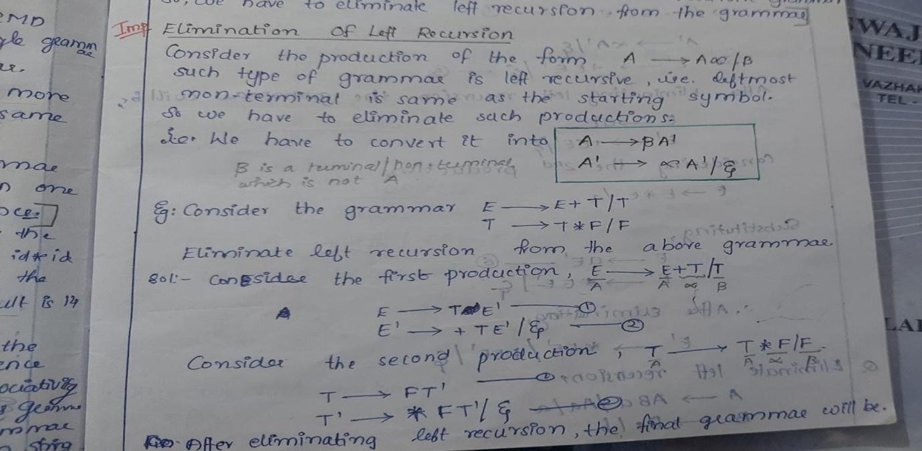
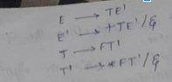
- Find FIRST set and FOLLOW set of each nonterminal in the following grammar E—>EAE|(E)|-E|id A—>+|*
FIRST(E) = { (, -, id } FIRST(A) = { +, * }
FOLLOW(E) = { $, ), + ,*} FOLLOW(A) = FIRST(E)= { (, -, id }
- What are viable prefixes?
  - A viable prefix refers to a prefix of the right-hand side of a production rule that can appear on the stack during the process of parsing or derivation. It represents the part of a sentential form that has been successfully matched by the parser.
  - Viable prefixes are prefixes of right-sentential forms that can be extended further in the parsing process using the production rules of a grammar. They are essential in the context of LR parsing and help in constructing efficient and accurate parsers for programming languages.
α is a viable prefix of the grammar if
- There is a w such that α w is a right sentential form
- α .w is a configuration of the shift reduce parser
. As long as the parser has viable prefixes on the stack no parser error has been seen
. The set of viable prefixes is a regular language (not obvious)
. Construct an automaton that accepts viable prefixes
The set of prefixes of right sequential forms that can appear on the stack of a shift-reduce parser are called viable prefixes. It is always possible to add terminal symbols to the end of a viable prefix to obtain a right-sentential form. Thus, as long as we are able to reduce the portion on the stack to a viable prefix, we are safe and no error occurs. Or to say, the input is accepted by the parser if we are able to manage viable prefixes as we consume the input, and at the last, we are left with the start symbol on the stack. The set of viable prefixes is a regular expression. This is not so obvious, but soon we are going to define the states for such an automaton which can accept viable prefixes.
- What are the different parsing conflicts in SLR Parsing Table
SLR (Simple LR) parsing table can encounter three types of parsing conflicts:
  - Shift-Reduce Conflict:
    - Occurs when a parser state has both a shift and a reduce action for the same input symbol.
    - This conflict arises when the grammar is ambiguous or when the parser cannot determine whether to shift the next input symbol or reduce the current stack of symbols.
    - Resolving this conflict requires resolving the ambiguity in the grammar or adjusting the parsing rules.
  - Reduce-Reduce Conflict:
    - Occurs when a parser state has multiple reduce actions for the same input symbol.
    - This conflict arises when the grammar is ambiguous and can produce multiple valid parse trees for the same input.
    - Resolving this conflict requires eliminating the ambiguity in the grammar by rewriting or reorganizing the production rules.
These conflicts indicate situations where the parser encounters ambiguities or lacks sufficient information to determine the correct parsing action. Resolving these conflicts typically involves modifying the grammar or adjusting the parsing algorithm to remove the ambiguity and allow for a deterministic parsing process.

- Differentiate between synthesised attributes and Inherited attributes with an example
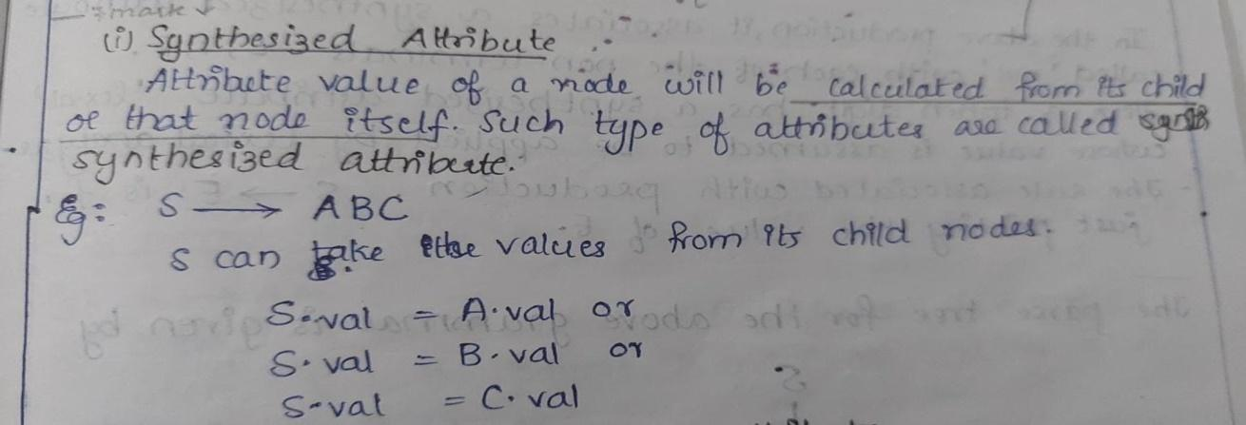

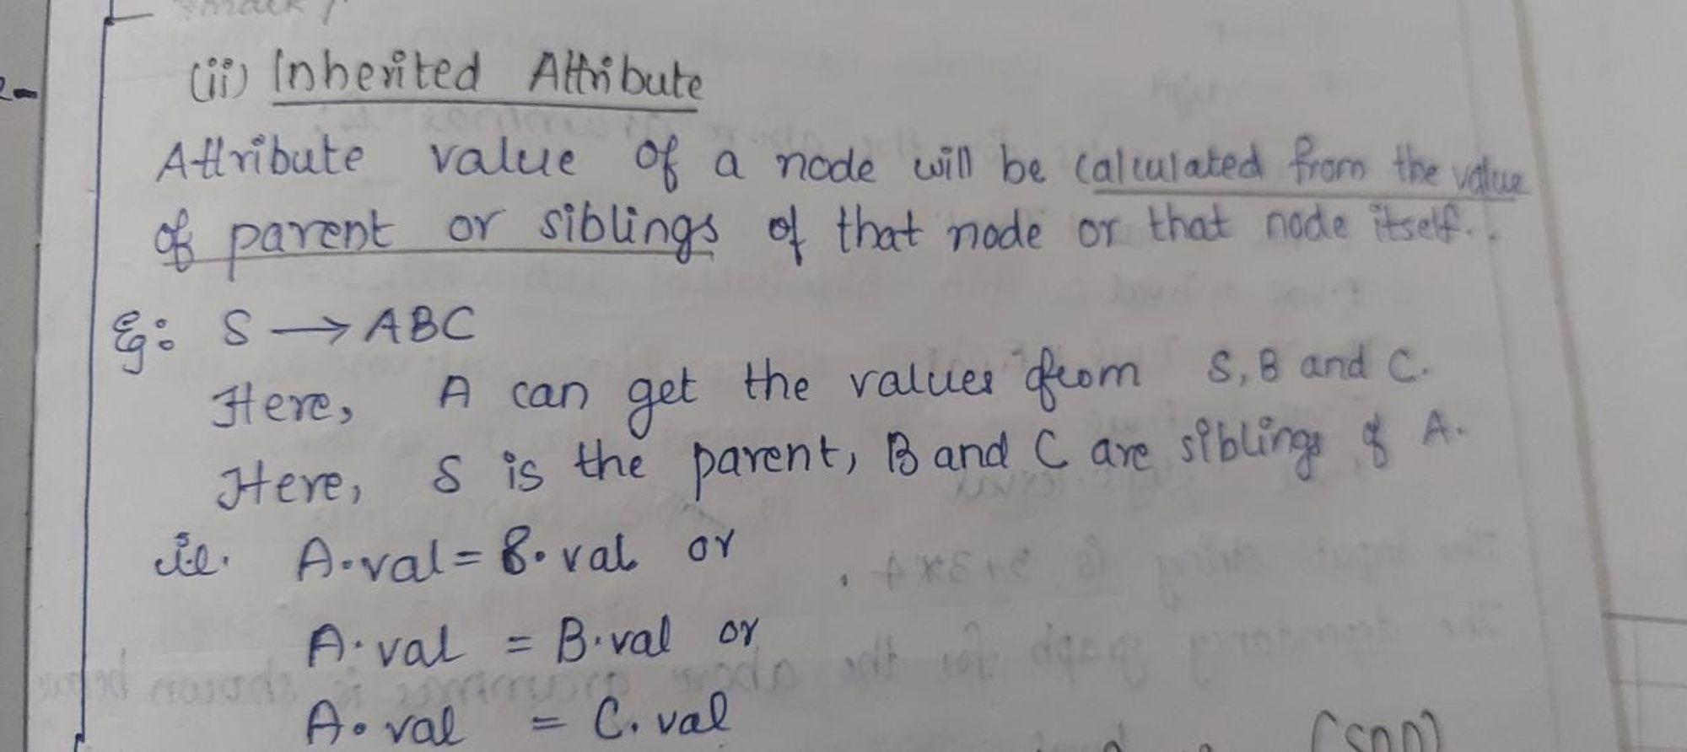
- What is the role of activation record in compiler design?
In compiler design, an activation record, also known as a stack frame or activation frame, plays a crucial role in managing the execution of functions or procedures during program execution. It is a data structure used by a compiler or runtime system to manage the dynamic storage and execution context of a function or procedure. The activation record is typically stored on the call stack.
The role of an activation record includes the following:
  - Local Variable Storage: The activation record contains space to store local variables and temporary values used within a function or procedure. This space is allocated when the function or procedure is called and deallocated when the execution returns from it.
  - Return Address: The activation record stores the return address, which is the memory address where the execution should resume once the function or procedure finishes its execution.
  - Parameter Passing: The activation record stores the parameters passed to the function or procedure. This allows the function or procedure to access and manipulate the values of its parameters during execution.
  - Control Link or Frame Pointer: The activation record may include a control link or frame pointer that points to the activation record of the calling function or procedure. This enables the nested structure of function calls and facilitates access to variables and parameters from higher-level scopes.
  - Dynamic Link: In languages that support nested functions or procedures, the activation record may include a dynamic link that points to the activation record of the lexical parent function or procedure. This allows for access to variables and parameters from the enclosing scopes.

Overall, the activation record provides a structured mechanism for managing the execution context, variable storage, parameter passing, and control flow during the execution of functions or procedures. It helps ensure proper memory management, function call sequencing, and access to variables and parameters in a structured and efficient manner.
- Explain Code motion with an example
An important modification that decreases the amount of code in a loop is code motion.
A fragment of code that resides in the loop and computes the same value at each iteration is called a loop-invariant code. This code can be moved out of the loop by saving it to be computed only once, rather than with each iteration.

For example, evaluation of limit-2 is a loop-invariant computation in the following while-statement:
while (i <= limit-2) /* statement does not change limit*/
Code motion will result in the following
t= limit-2;
while (i<=t) /* statement does not change limit or t */
Example2:
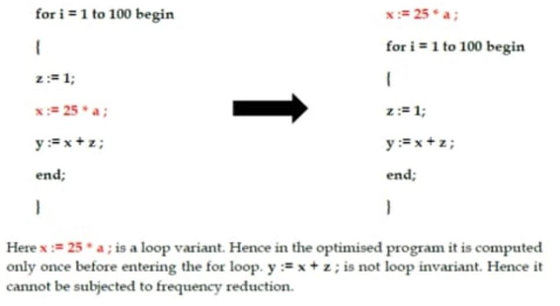

- Write the algorithm for partitioning a sequence of three-address instructions into basic blocks
Algorithm:
Partitioning three-address code into basic blocks.
Input: A sequence of three address instructions.
Process: Instructions from intermediate code which are leaders are determined. Following are the rules used for finding a leader:
- The first three-address instruction of the intermediate code is a leader.
- Instructions that are targets of unconditional or conditional jump/goto statements are leaders.
- Instructions that immediately follow unconditional or conditional jump/goto statements are considered leaders.
For each leader thus determined its basic block contains itself and all instructions up to excluding the next leader.

PART-B
- a. Explain the working of different phases of a compiler. Illustrate with a source language statement. (8)
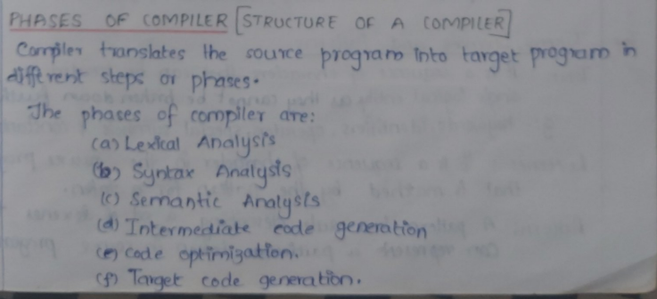
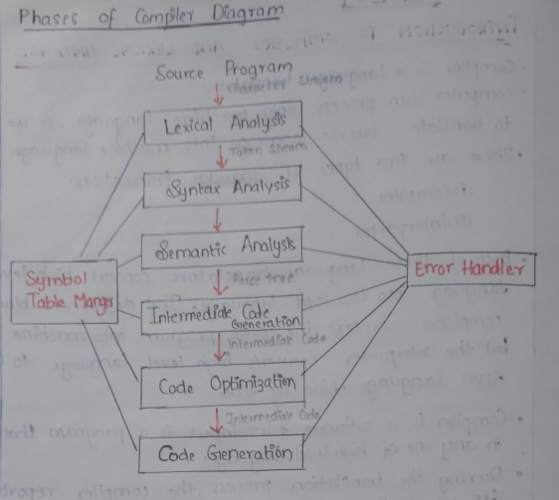

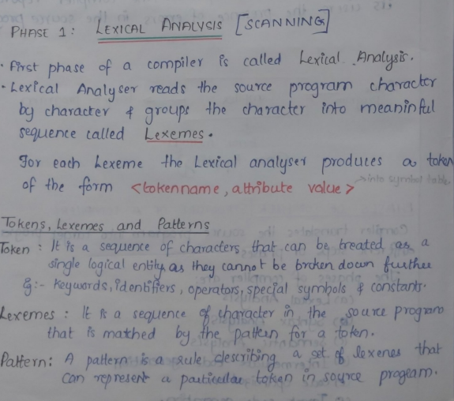
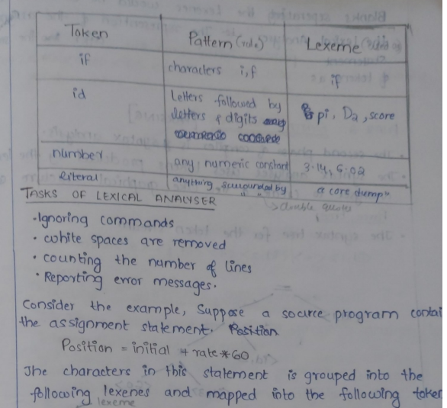
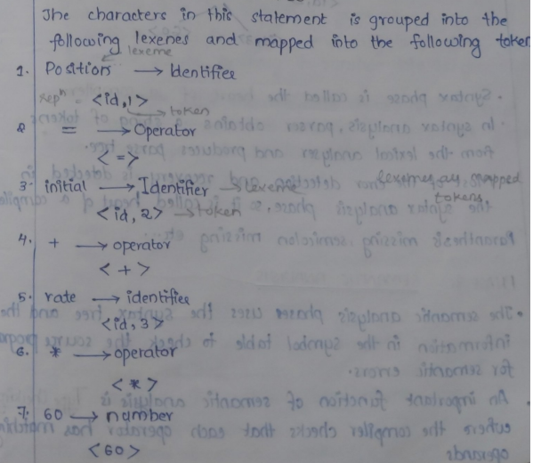

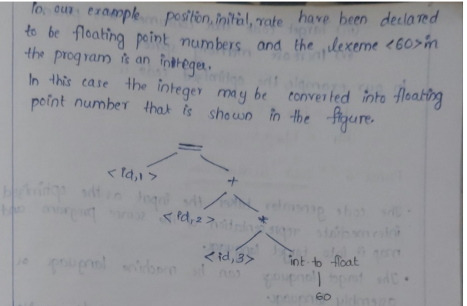
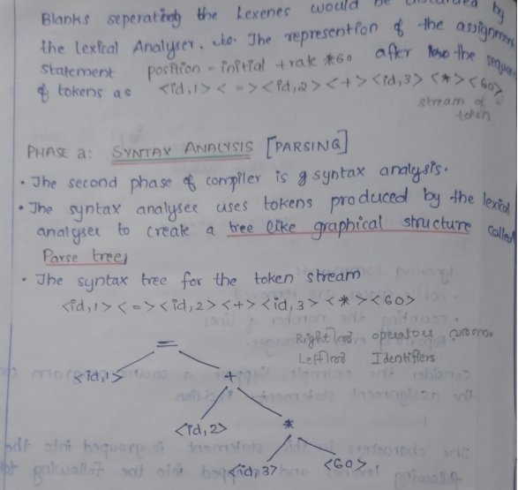
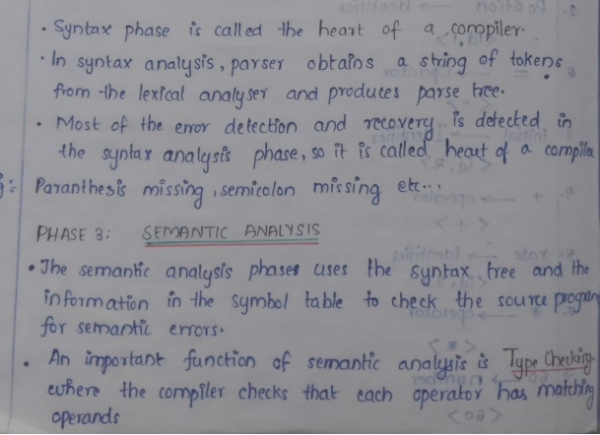

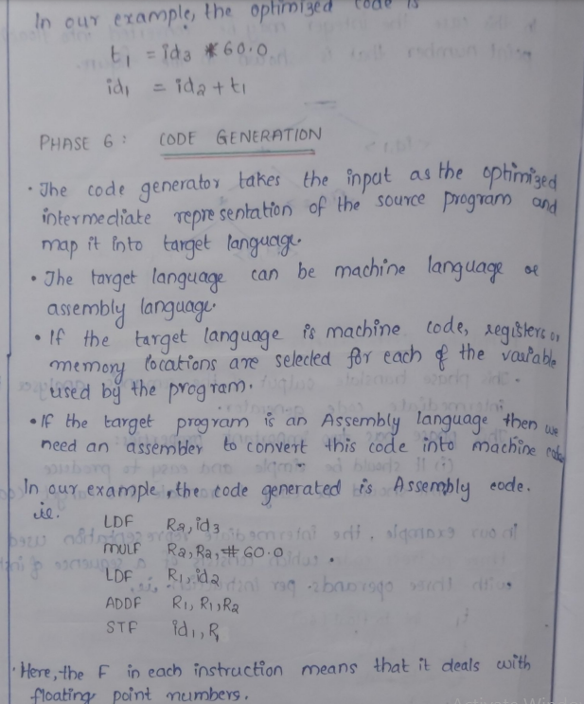
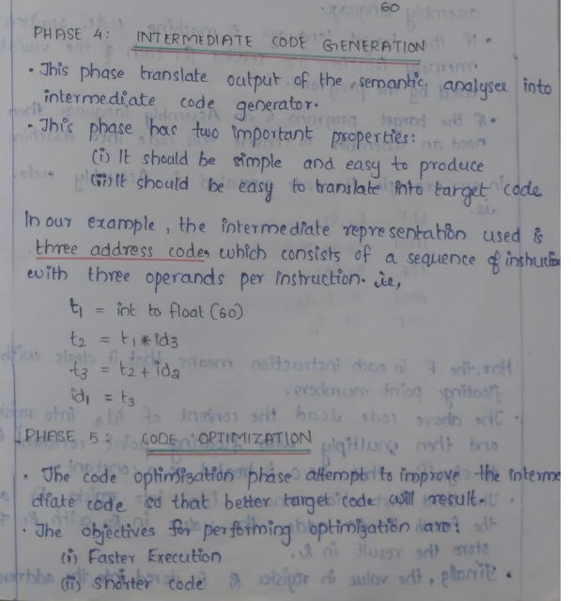
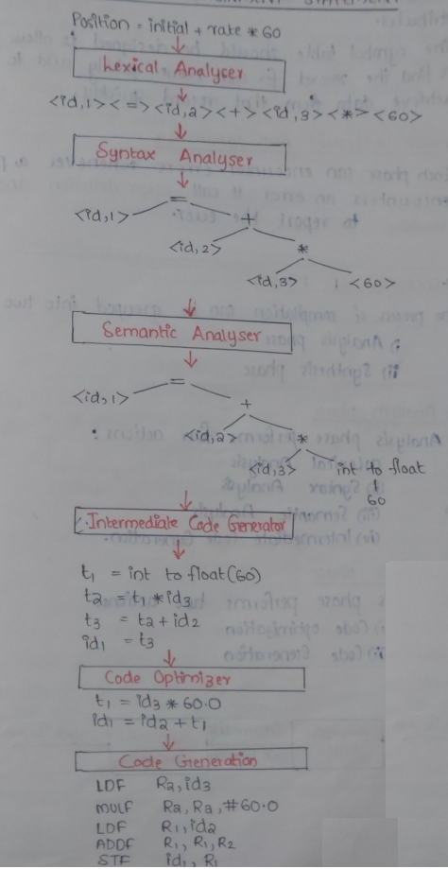

b) Explain different compiler construction tools. (6)
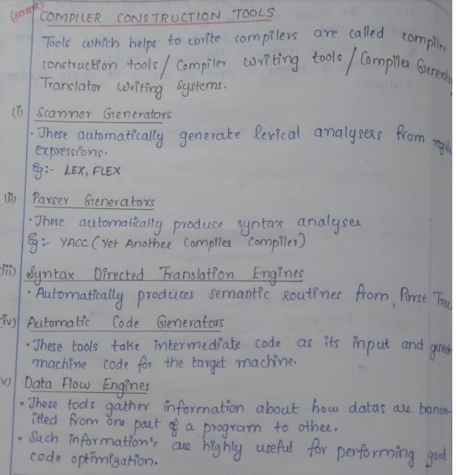

- a)Explain the role of transition diagrams in recognition of tokens. (7)
The role of transition diagrams in token recognition can be summarized as follows:
- Token Definition: Transition diagrams are used to define the structure and patterns of tokens in a formal and visual manner. Each token type (such as identifiers, keywords, numbers, operators, etc.) is associated with a specific transition diagram.
- State Transitions: Transition diagrams represent the states of a finite-state machine, where each state corresponds to a particular configuration or context. The transitions between states are triggered by input symbols or characters.
- Token Recognition: When the lexical analyzer reads characters from the input stream, it traverses the transition diagram based on the current state and the incoming input symbol. By following the transitions, the finite-state machine moves from one state to another, building the token incrementally.
- Accepting States: Transition diagrams have accepting states or final states. When the finite-state machine reaches an accepting state, it indicates that a complete token has been recognized. At this point, the lexical analyzer can return the token to the parser for further processing.
- Error Handling: Transition diagrams can incorporate error states or transitions to handle invalid or unrecognized input. If the lexical analyzer encounters a character that does not match any transition in the diagram, it can transition to an error state, indicating a lexical error.

b). Explain bootstrapping with an example. (7)
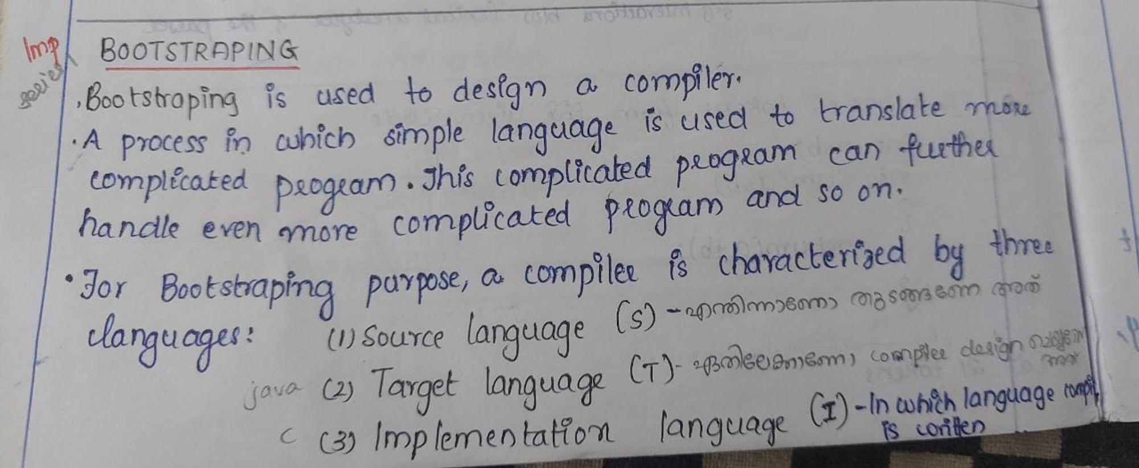
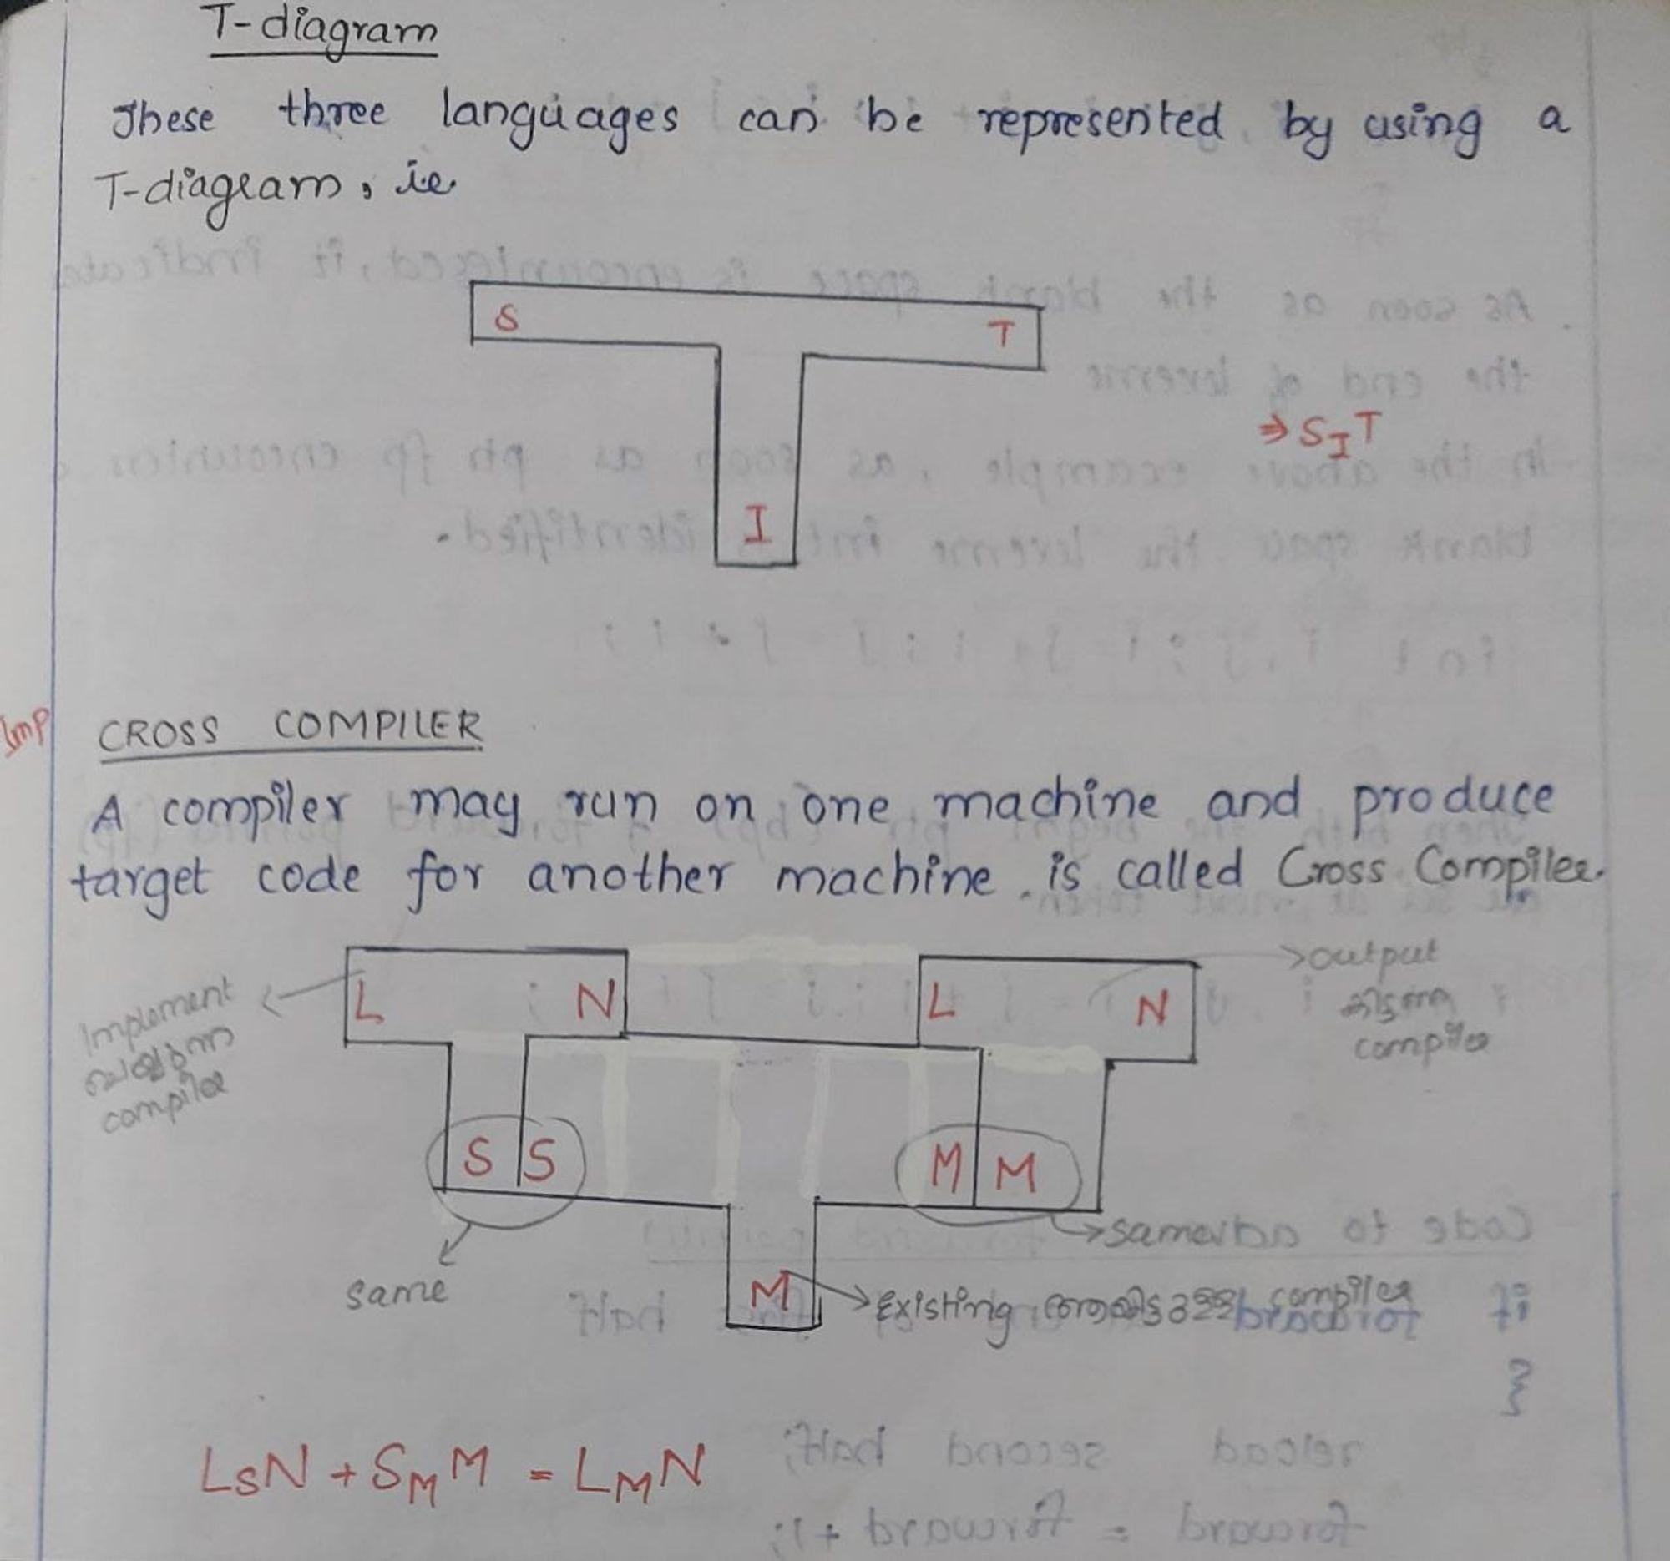
13. a. i)Show that the grammar S→iCtSeS /iCtS / b, C->a is ambiguous. ii)Eliminate ambiguity from the above grammar. (6)
Now, let's try to derive the string "iatiatbeb" using this grammar in two different leftmost derivation ways:
S ⇒ iCtSeS ⇒ iatSeS ⇒ iatiCtSeS => iatiatSeS => iatiatbeS => iatiatbeb
S ⇒ iCtS ⇒ iatS ⇒ iatiCtSeS => iatiatSeS => iatiatbeS => iatiatbeb
Since there are two leftmost derivations possible for the string iatiatbeb using the above grammar, the given grammar is ambiguous.

ii) To eliminate ambiguity from the grammar, we need to modify the production rules to ensure that each string has only one valid parse tree. Here's a modified unambiguous grammar:
S -> iTX | b
X -> CtSeS | CtS
C -> a
In this modified grammar, we introduced a new non-terminal X to handle the ambiguity. The rule S -> iTX allows for a non-terminal X to appear after i, while the rule X -> CtSeS | CtS specifies that the non-terminal X can expand to either CtSeS or CtS. This ensures that the sequence of CtSeS can only appear after i, and there is no ambiguity in the derivation.
b) Construct a Recursive descent Parser for handling Arithmetic Expressions. (8)
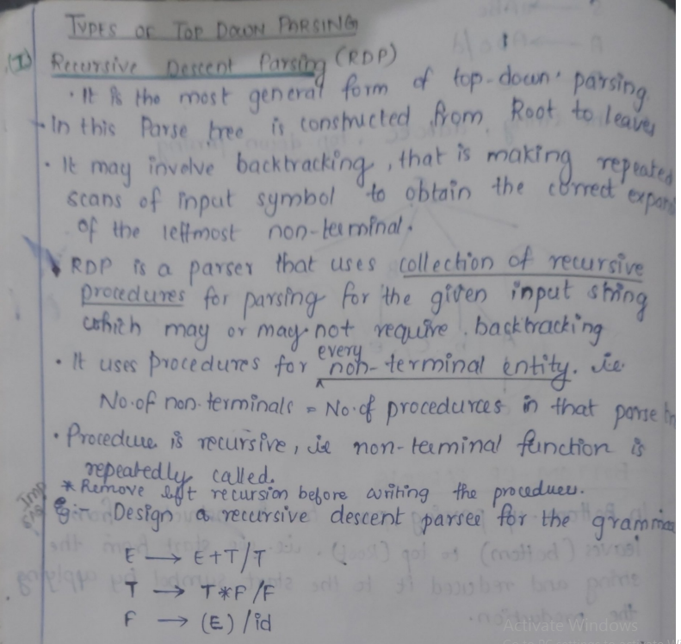
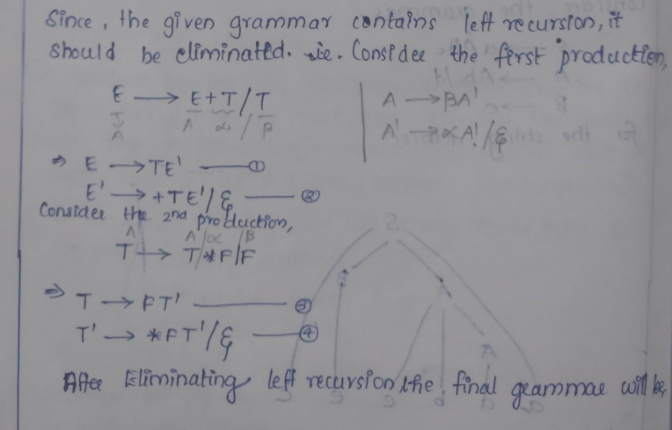
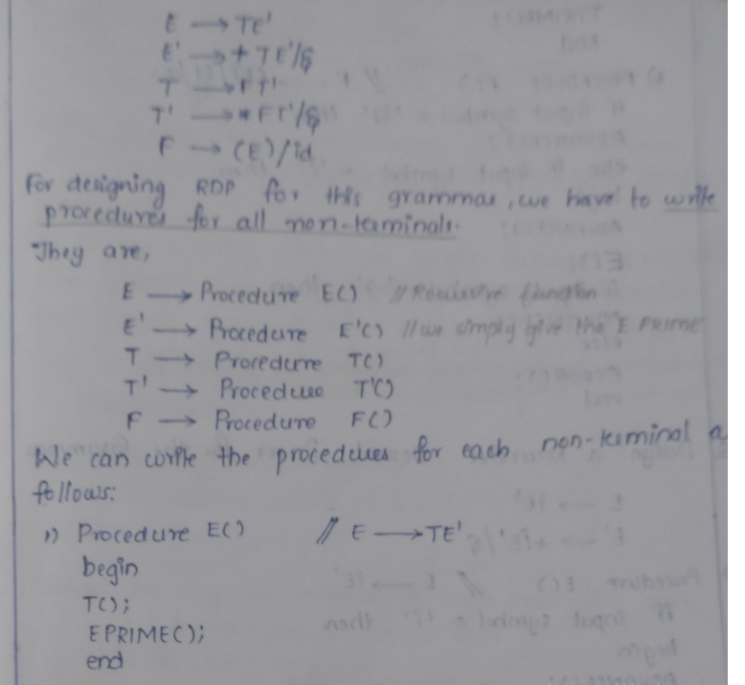

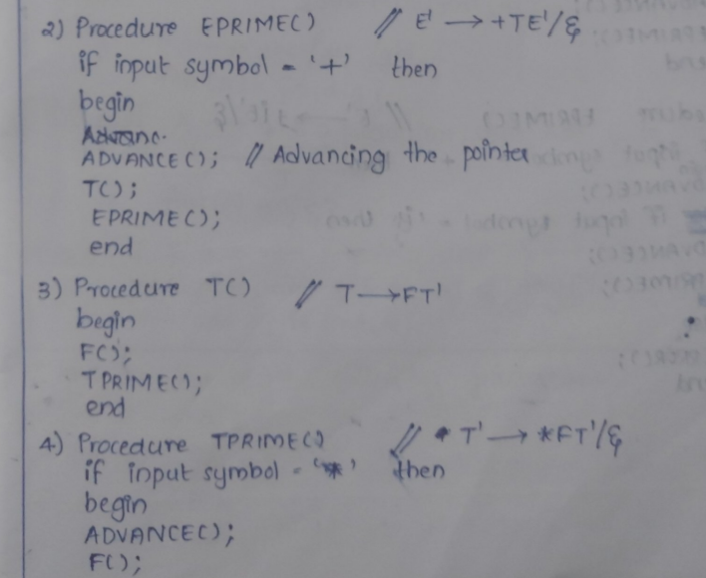
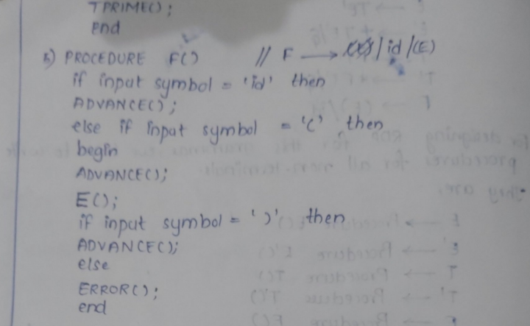

14.a)Write Non-recursive predictive parsing algorithm. (6)
- Define a parsing table: Create a parsing table that maps non-terminals to terminals or epsilon (empty) transitions. Each table entry represents a production rule that should be applied when encountering a particular non-terminal and lookahead terminal.
- Initialize the stack: Create an empty stack and push the start symbol onto it.
- Read input: Read the next token from the input.
- Repeat until the stack is empty:
  - If the top of the stack is a non-terminal:
    - Look up the parsing table entry for the current non-terminal and the current lookahead token.
    - If the entry is empty or contains an error, report a syntax error.
    - Otherwise, replace the non-terminal on top of the stack with the right-hand side of the production rule from the parsing table entry (in reverse order).
  - If the top of the stack is a terminal:
    - If it matches the current lookahead token, consume the token and pop the stack.
    - Otherwise, report a syntax error.
- If the input is fully consumed and the stack is empty, the input is syntactically correct. Otherwise, report a syntax error.
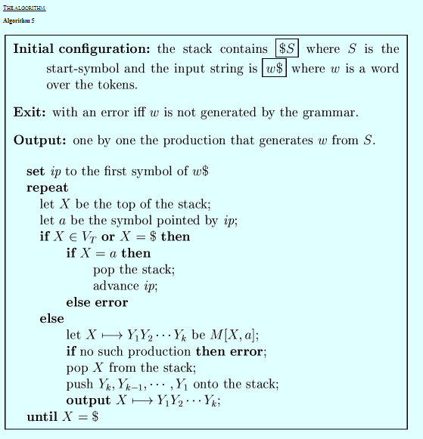

b). b) Prove that the following grammar is not in LL(1) (8)
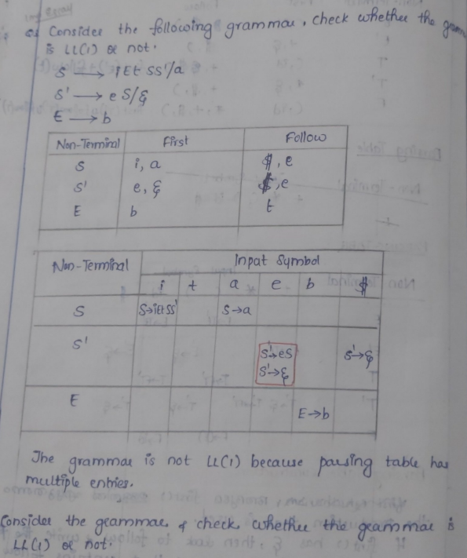

15.a. Construct canonical LR(0) collection of items for the grammar below. (9)
S → L = R | R
L → * R | id
R → L
Prove that this grammar is not SLR(1).
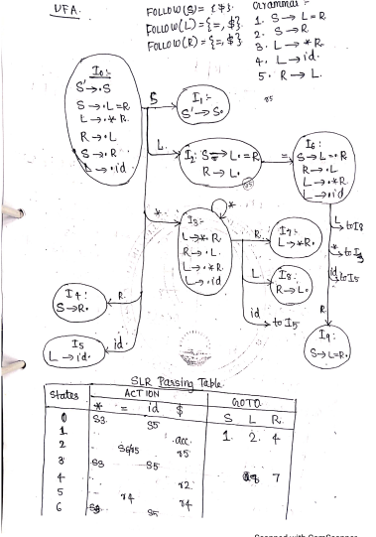
Since there are multiple entries in a cell in SLR Table, the grammar is not SLR.

15b. What is handle pruning? Indicate the handles in the reduction of the sentence aaabbb to the start symbol using the grammar S → aABb , A → aA | a , B → bB | b (5)
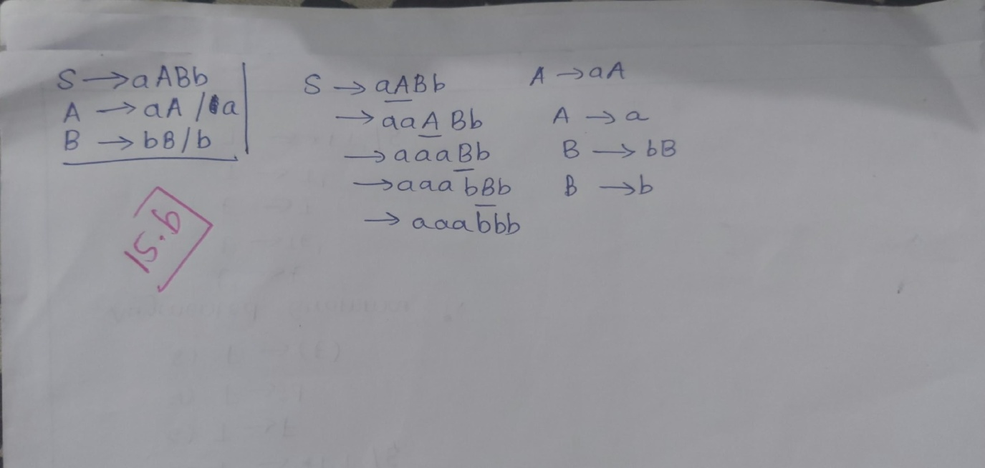

The handles are aA, a, bB and b

16. a Derive LR (1) parsing table for following grammar (9)
S → Aa | bAc | Bc | bBa
A → d
B → d

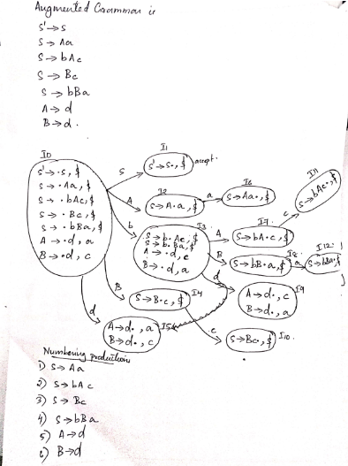

LR(1) Parsing Table for the above grammar is as follows

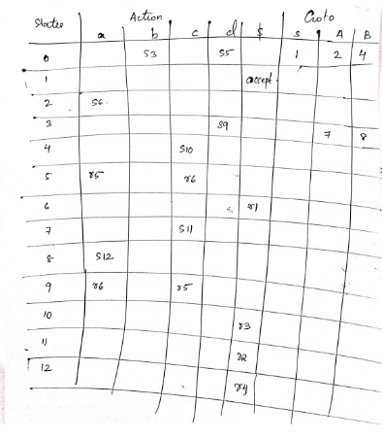

16 b) Write all moves by the LR parser for parsing the input ‘bdc’. [ use the parsing table created in question number 16.a] (5)
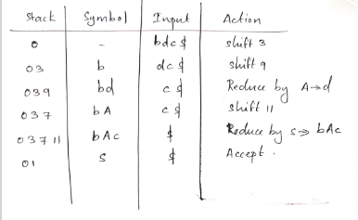

17.a. Write the SDD for a simple type declaration and draw the annotated parse tree for the declaration float a,b,c. (7)
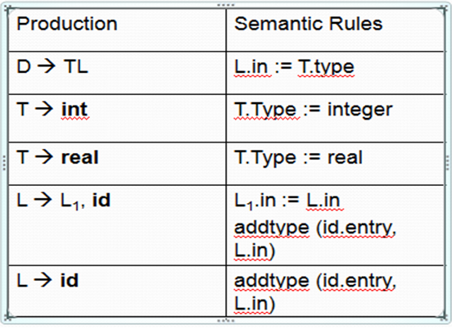

17. b. With an SDD for a desk calculator, write the steps involved in the bottom up evaluation for the expression (3*5) -2. (7)
Grammar Semantic Rule
E → E + T E.val = E.val + T.val
E → E - T E.val = E.val - T.val
E → T E.val = T.val
T → T * F T.val = T.val * F.val
T → T / F T.val = T.val / F.val
T → F T.val = F.val
F → (E) F.val = E.val
F → num F.val = num.lexval
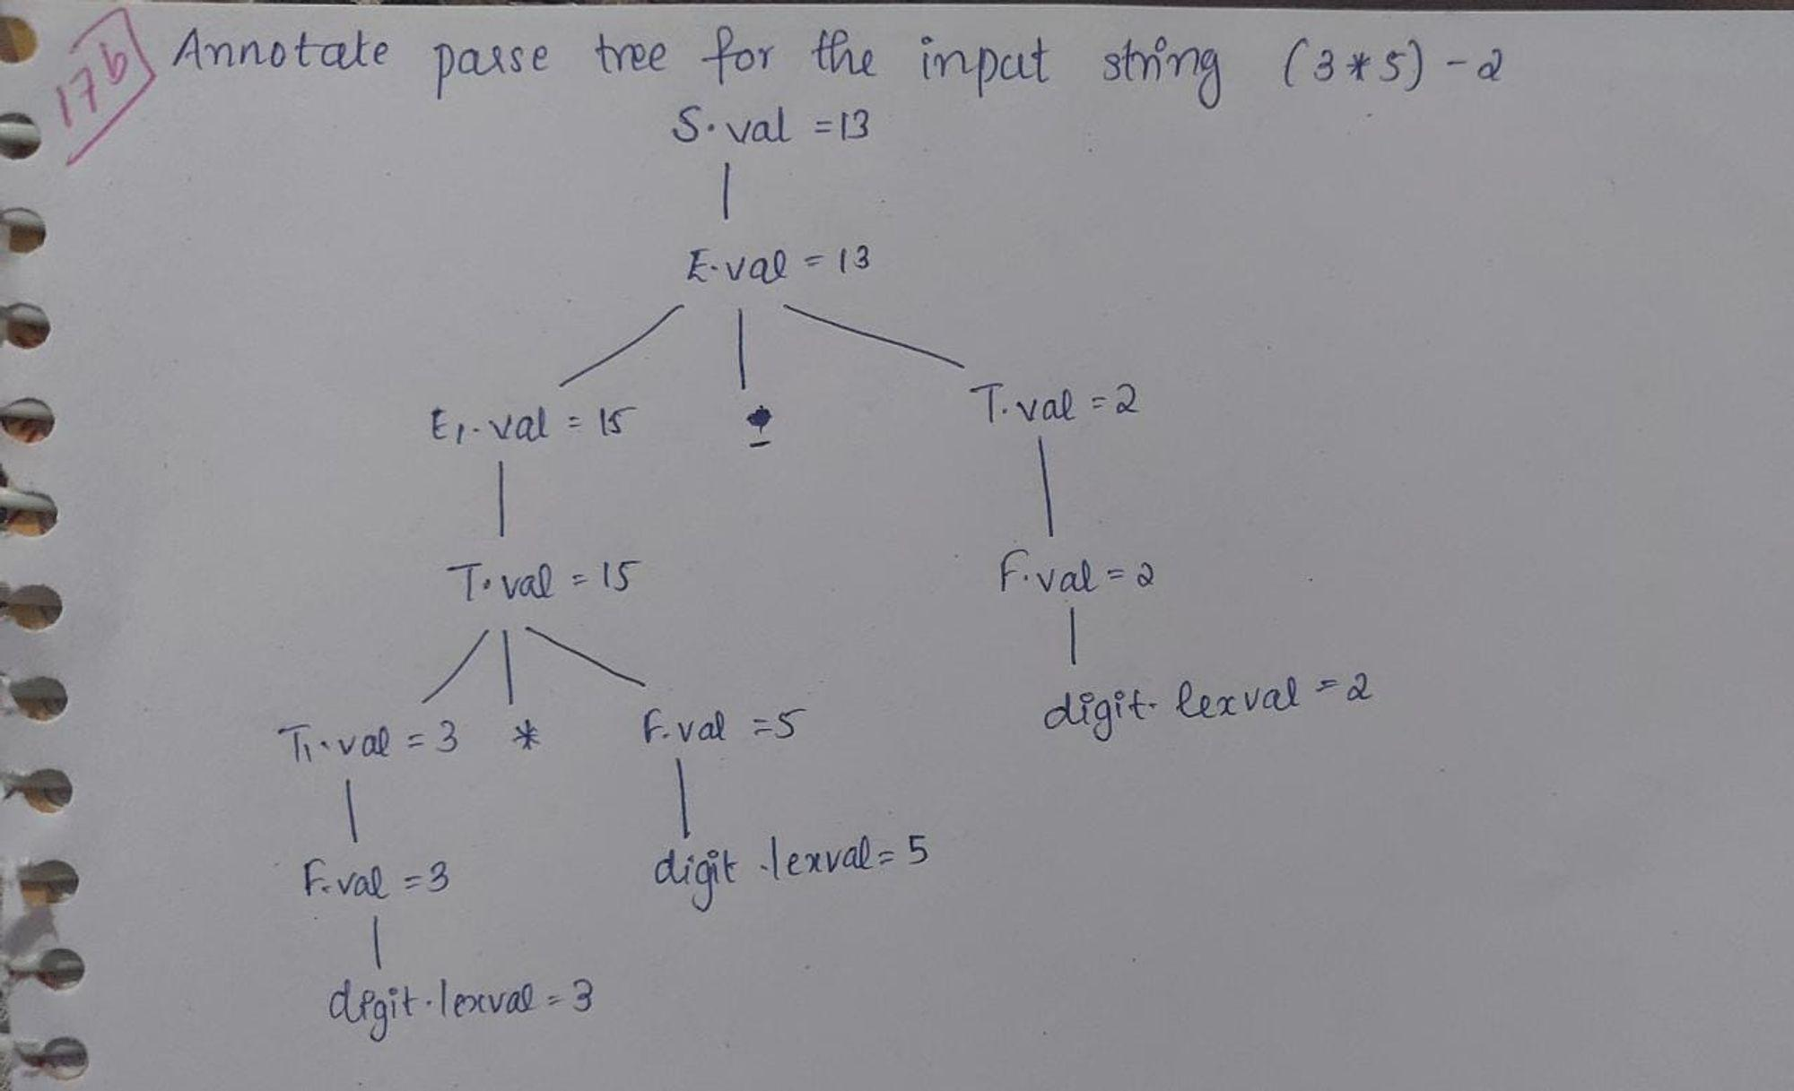
18.a Explain static allocation and heap allocation strategies? (7)
In compiler design, static allocation and heap allocation are two different strategies for managing memory during the execution of a program. These strategies determine how memory is allocated and deallocated for variables and data structures.
- Static Allocation: Static allocation refers to the process of assigning memory to variables and data structures at compile-time. The memory is allocated in a predetermined manner, and the allocation remains fixed throughout the program's execution. This strategy is typically used for variables and data structures that have a fixed size and lifetime.
Key characteristics of static allocation:
- Memory allocation is done during the compilation phase.
- The memory is allocated from a fixed-size block of memory known as the stack.
- Variables have a fixed memory location and are bound to their memory addresses at compile-time.
- Allocation and deallocation of memory are handled automatically by the compiler.
- Static allocation is efficient and provides fast access to variables.
- The memory allocated for variables is automatically released when they go out of scope.
Static allocation is commonly used for local variables, function parameters, and other variables with a limited scope and lifetime.
- Heap Allocation: Heap allocation involves dynamic memory allocation during the program's execution. It allows for the allocation and deallocation of memory blocks of varying sizes at runtime. The heap is a large pool of memory that can be dynamically managed by the program.
Key characteristics of heap allocation:
- Memory allocation is performed dynamically at runtime using functions like malloc() or new (in languages like C and C++).
- Memory is allocated from the heap, which is a larger memory space than the stack.
- Variables and data structures have a more flexible lifetime and can persist beyond their lexical scope.
- Heap-allocated memory needs to be explicitly deallocated using functions like free() or delete (in C and C++).
- Heap allocation allows for the dynamic creation and resizing of data structures like arrays and linked lists.
- It provides greater flexibility but can be slower than static allocation due to the overhead of dynamic memory management.

18.b) Construct the DAG and three address code for the expression a+a*(b-c)+(b-c)*d (7)
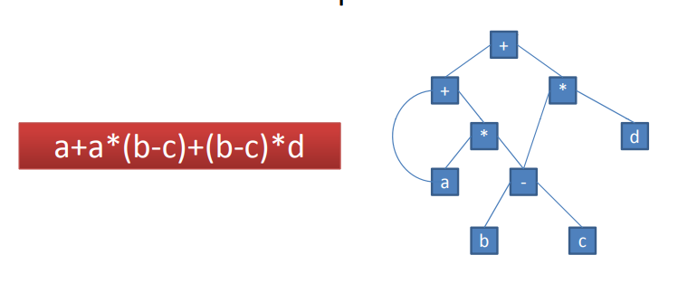
Three address code:
t1=b-c
t2=a*t1
t3=t1*d
t4=a+t2
t5=t4+t3

19.a With suitable examples explain loop optimization techniques (7)
- The running time of a program may be improved if we decrease the number of instructions in an inner loop, even if we increase the amount of code outside that loop.
- Three techniques are important for loop optimization:
  - Code Motion, which moves code outside a loop;

B) Induction-variable elimination, which we apply to replace variables from inner loop.

C) Reduction in Strength, which replaces expensive operation by a cheaper one, such as a multiplication by an addition.

A) Code Motion (or Frequency Reduction)
- An important modification that decreases the amount of code in a loop is code motion.

- A fragment of code that resides in the loop and computes the same value at each iteration is called a loop-invariant code. This code can be moved out of the loop by saving it to be computed only once, rather than with each iteration.
- For example, evaluation of limit-2 is a loop-invariant computation in the following while-statement:
while (i <= limit-2) /* statement does not change limit*/
Code motion will result in the following
t= limit-2;
while (i<=t) /* statement does not change limit or t */

B) Induction Variables :
- A variable is called an induction variable if its value is altered within the loop by a loop-invariant value.
- 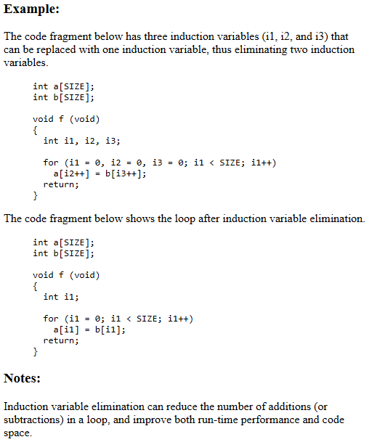

C) Reduction In Strength:
- Reduction in strength replaces expensive operations by equivalent cheaper ones on the target machine.

- Certain machine instructions are considerably cheaper than others and can often be used as special case of more expensive operators.
  - For example, x² is invariably cheaper to implement as x*x than as a call to an exponentiation routine.
  - Fixed-point multiplication or division by a power of two is cheaper to implement as a shift.
  - Floating-point division by a constant can be implemented as multiplication by a constant, which may be cheaper.

Example: Replacement of a multiplication by an addition
- Here, high strength operator ‘*’ in ‘i*5’ occurring inside loop is replaced by a low strength operator ‘+’ in ‘itemp+5’
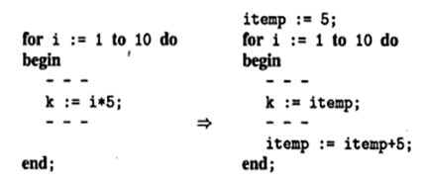

19.b With suitable example of a basic block, explain the code-improving transformations of a basic block. (7)
There are two types of basic block optimizations or transformations.

They are:
1. Structure-Preserving Transformations
2. Algebraic Transformations

1. Structure-Preserving Transformations:
- The primary Structure-Preserving Transformation on basic blocks are:
  - Common sub-expression elimination.
  - Dead code elimination.
  - Renaming of temporary variables
  - Interchange of two independent adjacent statements.

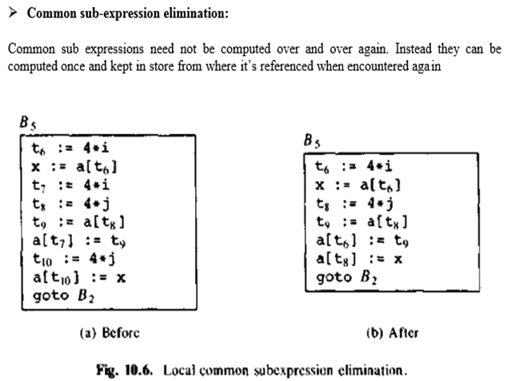
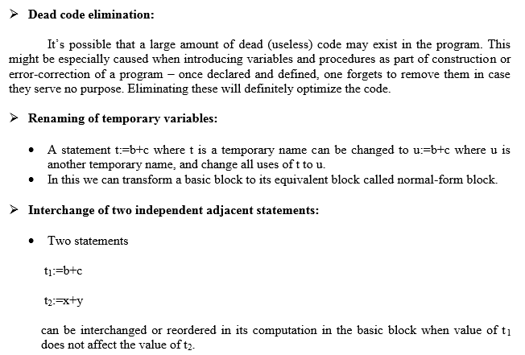
2. Algebraic Transformations
- Algebraic identities represent another important class of optimizations on basic blocks.
  - Example:
x+0 = 0+x = x
x-0 = x
x*1 = 1*x = x
x/1 = x

- Another class of algebraic optimisation includes replacing an expensive operation by cheaper ones i.e. reduction in strength.
  - Example:
x ** 2 = x*x
2.0*x = x+x
x/2 = x*0.5
- Another class of algebraic related optimizations is constant folding.
  - Here we evaluate constant expressions at compile time and replace the constant expressions by their values.
  - Thus the expression 2*3.14 would be replaced by 6.28.

20.a Explain issues in code generator (6)
In the code generation phase, various issues can arises:
- Input to the code generator
- Target program
- Memory management
- Instruction selection
- Register allocation
- Evaluation order
1. Input to the code generator
- The input to the code generator contains the intermediate representation of the source program and the information of the symbol table. The source program is produced by the front end.
- Intermediate representation has the several choices:
a) Postfix notation
b) Syntax tree
c) Three address code
- We assume front end produces low-level intermediate representation i.e. values of names in it can directly manipulated by the machine instructions.
- The code generation phase needs complete error-free intermediate code as an input requires.
2. Target program:
The target program is the output of the code generator. The output can be:
a) Assembly language: It allows subprogram to be separately compiled.
b) Relocatable machine language: It makes the process of code generation easier.
c) Absolute machine language: It can be placed in a fixed location in memory and can be executed immediately.
3. Memory management
- During code generation process the symbol table entries have to be mapped to actual p addresses and levels have to be mapped to instruction address.
- Mapping name in the source program to address of data is co-operating done by the front end and code generator.
- Local variables are stack allocation in the activation record while global variables are in static area.
4. Instruction selection:
- Nature of instruction set of the target machine should be complete and uniform.
- When you consider the efficiency of target machine then the instruction speed and machine idioms are important factors.
- The quality of the generated code can be determined by its speed and size.

5. Register allocation
Register can be accessed faster than memory. The instructions involving operands in register are shorter and faster than those involving in memory operand.
The following sub problems arise when we use registers:
Register allocation: In register allocation, we select the set of variables that will reside in register.
Register assignment: In Register assignment, we pick the register that contains variable.
Certain machine requires even-odd pairs of registers for some operands and result.

6. Evaluation order
The efficiency of the target code can be affected by the order in which the computations are performed. Some computation orders need fewer registers to hold results of intermediate than others

b) Write the code generation algorithm. Using this algorithm generate code sequence for the expression d : = (a-b) + (a-c) + (a-c) (8)

Code Generation Algorithm
- The algorithm takes as input a sequence of three-address statements constituting a basic block.

- For each three-address statement of the form x : = y op z, perform the following actions:

1. Invoke a function getreg to determine the location L where the result of the computation y op z should be stored.

2. Consult the address descriptor for y to determine y’, the current location of y. Prefer the register for y’ if the value of y is currently both in memory and a register. If the value of y is not already in L, generate the instruction MOV y’ , L to place a copy of y in L.

3. Generate the instruction OP z’ , L where z’ is a current location of z. Prefer a register to a memory location if z is in both. Update the address descriptor of x to indicate that x is in location L. If x is in L, update its descriptor and remove x from all other descriptors.

4. If the current values of y or z have no next uses, are not live on exit from the block, and are in registers, alter the register descriptor to indicate that, after execution of x : = y op z , those registers will no longer contain y or z.

The target code for the following statement
d:=(a-b)+(a-c)+(a-c)
